**THE TREASURE HUNT PUZZLE.**

The project the treasure hunt is an interactive puzzle with a unique storyline.

**Storyline:**

A thief RAJVEER must rob the treasure in the train so that he can take revenge on his enemy John Brook a British chancellor at Madras.

RAJVEER doesn’t know what the treasure and he is most wanted by the British soldiers.

By the clues, he knows that John Brook is on his deathbed with a disease that has no cure.

By the same clues, he knows the treasure is an ancient medicine book that has the cure for John Brook's disease if he stoles that book, John Brook will die.

**Setup and gameplay:**

this puzzle doesn’t need any prior setup. It starts on load and has interactive footers and buttons that will guide the player on what to do.

Puzzle has all its clues in the images placed in different places and in the text messages in the storyline.

**Soft skills assessed:**

This puzzle can assess 6 soft skills.

1. Curiosity
2. Prioritization
3. Detail oriented
4. Critical thinking
5. Observation
6. Analysis.

**Solutions and dead ends:**

**No of dead ends: 5**

1. Entering the goods compartment.

Reason: you cannot go back.

1. Fight with the pirates

Reason: There are 40 pirates he cannot fight with them

1. Calling the guards

Reason: he is most wanted he cannot call guards

1. Using a window to reach the treasure.

Reason: Secured vault has no windows

1. Finding the wrong treasure.

Reason: train reaches Madras soldiers caught him.

**No of Solutions: 3**

We have 3 different VIP coupons each one has different clues to find the treasure. These clues are hidden in the images in the room.

**Game flow:**

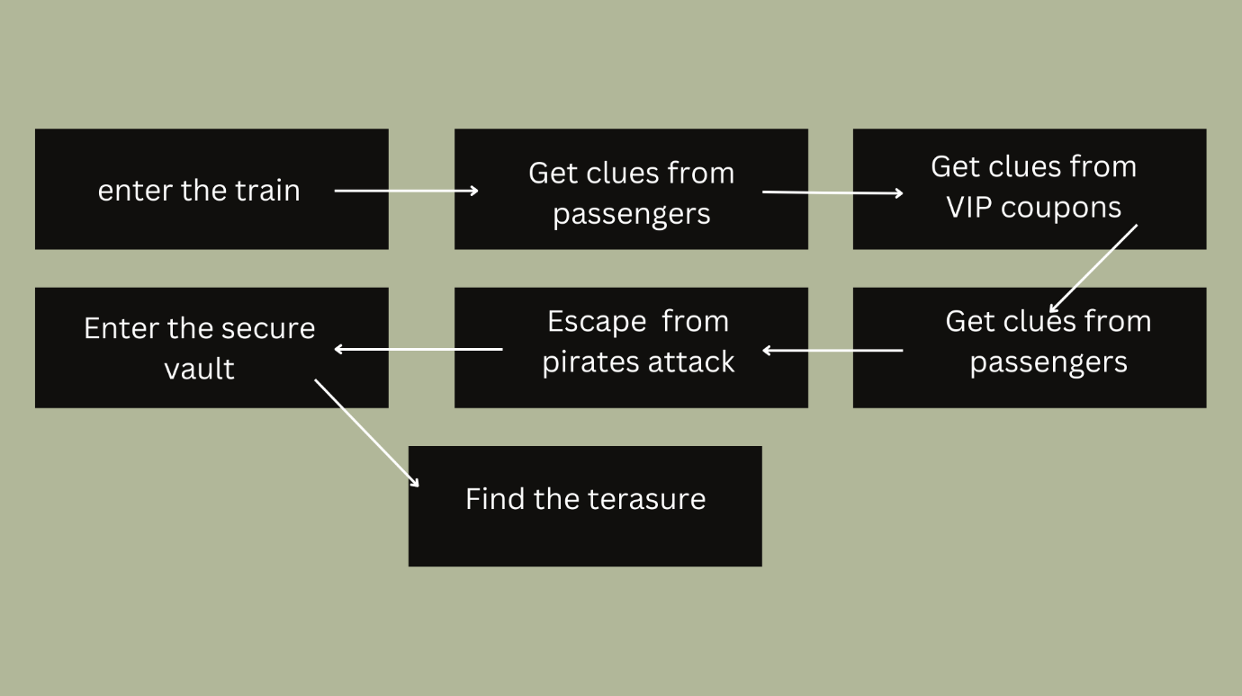

**Languages used:** JavaScript.

**Soft skills evaluation logic:** The soft skills of a person are calculated based on their chosen clues and ways to slove the puzzle. Hidden points are assigned to different soft skills. Displayed at the end.

**Screen Shots:**

